3GPP TSG RAN WG1 #125 R1-2604428
Dalian, China, May. 18th ~ 22nd, 2026

Agenda Item: 10.8.2
Source: Quectel
Title: Discussion on reference signal and resource allocation for 6G ISAC
Document for: Discussion

1.Introduction
Starting from this meeting, discussions on 6G ISAC have begun in RAN1. ISAC systems aim to provide both communication and sensing, but limited time-frequency resources challenge high-resolution range and Doppler estimation. Uniform sparse allocation improves resolution at the cost of reduced unambiguous range, non-uniform sparse allocation enhances resolution without reducing the unambiguous range though increases sidelobe levels, and structured sparse allocation with autocorrelation constructs “hole-free” virtual signals, achieving near full-bandwidth performance with limited resources. These strategies are proposed to optimize reference signal design and enhance sensing capabilities across diverse ISAC scenarios.

2 Sensing reference signal design
In RAN1#124b meeting, the following agreements on sensing RS are made for 6GR ISAC : [1]
Agreement:
- On RS for ISAC, study at least the following aspects, considering sensing performance, resource overhead and impact to communication
  - RS for communication is reused for sensing
  - Enhanced RS for sensing, taking reuse of RS for communication as starting point
    - Note: Part of or all of the RS may be used for communication purpose, and it does not mean the final decision on whether the enhanced RS is used for communication purpose is to be made in this agenda.
  - Dedicated RS for sensing

Agreement:
- Study RE patterns of RS for sensing, considering sensing performance, resource overhead and impact to communication
- Note: enhancements on RS sequence if any will be discussed in agenda 10.8.3

The primary reference signals in 5G NR include the SSB (comprising the PSS, SSS, and PBCH with DMRS), CSI‑RS, DMRS, and PT‑RS, among others. These signals serve different functions and are distributed differently in the time‑frequency resource grid, as shown in Fig. 1. If these reference signals are reused for target sensing, their respective advantages and disadvantages are summarized in Table 1.
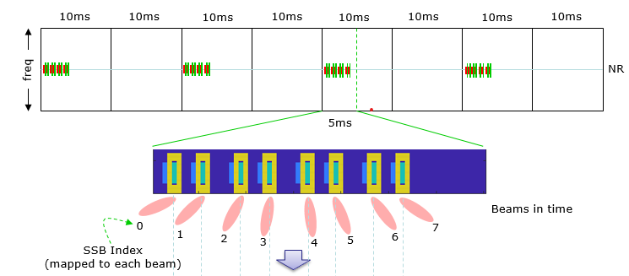
(a) SSB
(b) CSI-RS (c) DMRS+PTRS
Figure1 Time‑frequency resource mapping of reference signals.
Table 1 Advantages and disadvantages of reference signals for sensing.
 | Pros | Cons
SSB | - Periodic signals that are always present, independent of user data.  - Beam sweeping signals, providing angular sensing capability.  - Partially known signals, which can be used for multi- sensing. | - Short duration, low Doppler resolution.  - Narrow and contiguous frequency resources, low delay resolution.
DMRS/  PTRS | - Wide bandwidth and long duration, high delay and Doppler resolution. | - Beamforming directed toward the user, weaker sensing capability for targets in other directions.  - Uniform sparse time-frequency allocation resources drastically reduces the unambiguous range in delay and Doppler domains.
CSI-RS | - Modular sparsity in the frequency domain improves the delay resolution while keeping the unambiguous range unchanged. | - High sidelobes in delay estimation degrade target detection accuracy.

Observation 1: If the various reference signals of 5G NR are reused for target sensing, under the same beam, the SSB with its contiguous time‑frequency resource allocation provides low sensing resolution. In contrast, DMRS, PT‑RS, and CSI‑RS occupy time‑frequency resources in different sparse patterns, which can achieve higher sensing resolution but face issues such as reduced unambiguous range or high sidelobes.
Proposal 1: 3GPP should investigate enhancing the sensing performance of OFDM‑based waveforms by improving existing reference signals or designing dedicated sensing reference signals through sparse time‑frequency resource allocation, thereby achieving a trade‑off among resolution, unambiguous range, and sidelobe levels.
Reference signals generally use the Resource Element (RE) (1 subcarrier × 1 symbol) as the basic unit for time‑frequency resource allocation. Based on different sparse allocation patterns, they can be categorized into three classes: uniform sparse, non‑uniform sparse, and structured sparse.

2.1 Uniform sparse allocation scheme
(a) Collocated allocation (b) Uniform sparse allocation
Figure 2 Time-frequency resource allocation scheme of CP-OFDM
Figure 2 compares collocated and uniform sparse time-frequency resource allocation schemes. As shown in Figure 2(b), the uniform sparse resource allocation scheme can effectively expand the occupied signal frequency band and time duration, thereby significantly improving the sensing resolution for delay and Doppler. The sparsity of the uniform sparse allocation is determined by its sparsity steps, denoted as $η_{v}$ and $η_{τ}$ for the time and frequency dimensions, respectively. The collocated allocation in Figure 2(a) is a special case with sparsity steps$η_{v}=η_{τ}=1$. Under this time-frequency resource allocation scheme, the relationships between the system sensing resolution, maximum unambiguous range, and the sparsity are summarized in Table 2, where $K_{u}$ and $N_{u}$ are the total numbers of allocated subcarriers and OFDM symbols, respectively.
Table 2 Sensing resolution and unambiguous range of the uniform sparse scheme.
Parameter | Resolution | Unambiguous range
Delay | $$Δτ=\frac{1}{Δfη_{τ}K_{u}}$$ | $$τ_{u}=\frac{1}{Δfη_{τ}}$$
Doppler | $$Δν=\frac{1}{T_{o}η_{ν}N_{u}}$$ | $$ν_{u}=\frac{1}{T_{o}η_{ν}}$$
(a) $K_{u}=36,η_{τ}=1$ (b) $K_{u}=36,η_{τ}=4$ (c) $K_{u}=144, η_{τ}=1$
Figure 3 Periodograms of range sensing for collocated and uniform sparse allocations.
Taking range sensing as an example, with a subcarrier spacing of $∆f=120Khz$, Figure 3 compares the periodograms for range sensing with different numbers of subcarriers $K_{u}$ and sparsity $η_{τ}$. It can be observed that with a sparsity $η_{τ}=4$, a bandwidth spanned by $K_{u}=36$ subcarriers achieves a range resolution equivalent to that of a $K_{u}=144$ subcarrier bandwidth, while the maximum unambiguous range is reduced by a factor of 4 simultaneously.
Observation 2: For a given number of resources, as the sparsity factor increases by a factor of $η$, the uniformly sparse resource allocation method improves the resolution by a factor of $η$, while the unambiguous range is reduced by a factor of $η$.

2.2 Non-uniform sparse resource allocation
The non‑uniform sparse allocation scheme is a method that allocates time‑frequency resources in a discontinuous pattern with no fixed sparse spacing and no regular structure. Let the sets of time‑frequency resources allocated to the sensing signal under this scheme be denoted as $Π^{ns}$ and $Γ^{ns}$. Based on NUDFT for delay‑Doppler estimation, the periodogram under the non‑uniform sparse allocation can be expressed as
$$\left(p^{*},q^{*},w^{*}\right)=\arg{\max_{p,q,w}\frac{1}{N_{u}K_{u}}}{\left|\sum_{n∈Π_{u}^{\text{ns}}}{\sum_{k∈Γ_{u}^{\text{ns}}}{y\left[n,k\right]e^{-j2πv_{p}nT_{o}}e^{j2πτ_{q}Δfk}}}\right|}^{2}$$
Due to the non‑uniform sparse allocation, the expression in the above formula cannot be expanded directly; its resolution and unambiguous range can only be analyzed by examining the periodogram spectrum. Taking subcarrier allocation for range sensing as an example, assume a subcarrier spacing of $∆f=120 kHz$, and that 36 out of 144 subcarriers are available for allocation to sensing reference signals. Figure 4 compares the range sensing periodograms of two different non‑uniform sparse subcarrier sequences. It can be observed that, although these two non‑uniform sparse allocation patterns exhibit high‑sidelobe and low‑sidelobe characteristics, respectively, the unambiguous sensing range remains unchanged, and the resolution is equivalent to the full bandwidth of 144 subcarriers.
(a) High‑sidelobe (b) Low‑sidelobe
Figure 4 Range sensing periodogram with non‑uniform sparse subcarrier allocation in the frequency domain.
Observation 3: The non‑uniform sparse time‑frequency resource allocation scheme can achieve higher sensing resolution while keeping the maximum unambiguous range unchanged; however, the sidelobe level is increased along with it, thus requiring the design of sparse resource sequences with low sidelobes.

2.3 Structured sparse resource allocation
Allocating discontinuous time‑frequency resources based on specific sparse structures, such as coprime, nested, and sparse ruler based, and combining them with autocorrelation‑based methods for target sensing, represents an efficient approach to enhance sensing performance by exploiting sparse resource allocation.
- Coprime structure:
As shown in Figure 5, the resource set of a coprime structure consists of two uniform sparse sequences whose sparsity intervals $\left(N_{1},N_{2}\right)$ are coprime. The set of resource indices is $S=\left\{\left(0:N_{2}-1\right)N_{1}\right\}∪\{(0:N_{1}-1)N_{2}\}$, and the total number of occupied resources is $N=N_{1}+N_{2}-1$.
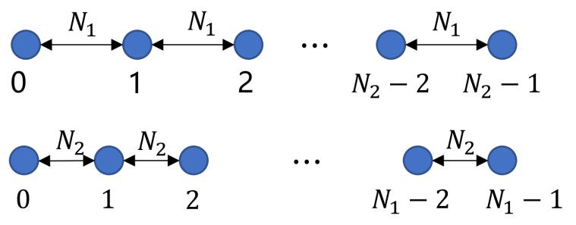
Figure 5 Coprime structure
- Nested structure:
As illustrated in Figure 6, the resource set of a nested structure comprises a contiguous resource sequence and a uniform sparse resource sequence. The set of resource indices is $S=\left\{0:N_{1}-1\right\}∪\left\{\left(1:N_{2}\right)N_{1}\right\}$, and the total number of occupied resources is $N=N_{1}+N_{2}$.
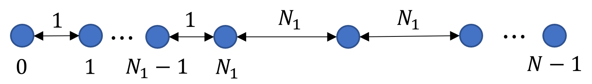
Figure 6 Nested structure
- Sparse ruler based structure:
Sparse ruler is a method for selecting sensing resources based on the generating formula of the Wichmann ruler. Its characteristic is that, given a total number of resources$N$, a smaller subset of resources is selected to transmit the sensing signal. The autocorrelation of this subset forms a virtual sensing signal containing all resource indices from 0 to $N-1$. The Wichmann ruler generates marker differences based on parameters $r$ and $s$, denoted as
$$W\left(r,s\right)=\{1^{r},r+1,{\left(2r+1\right)}^{r},{\left(4r+3\right)}^{s},{\left(2r+2\right)}^{r+1},1^{r}\}$$
where $1^{r}$ denotes the repetition of 1 for $r$ times, and ${\left(4r+3\right)}^{s}$ denotes the repetition of $(4r+3)$ for $s$ times. The Wichmann ruler with parameters $(r, s)$ has a mark count of $4r+s+3$, and its maximum ruler length is $4r^{2}+4rs+8r+3s+3$. Here, the mark count corresponds to the number of allocatable sensing resources, and the maximum ruler length does not exceed the total number of resources. Table 3 lists the parameter configurations of the Wichmann ruler and the corresponding minimum total resource numbers supported for different allocatable resource numbers.
Table 3 Sparse ruler based structure under different configurations
Allocatable resource number | Parameter $r$ | Parameter $s$ | minimum total resource number
10 | 1 | 3 | 36
11 | 1 | 4 | 43
12 | 1 | 5 | 50
13 | 1 | 6 | 57
14 | 2 | 3 | 68
15 | 2 | 4 | 79
16 | 2 | 5 | 90
17 | 2 | 6 | 101
18 | 2 | 7 | 112
19 | 2 | 8 | 123
20 | 3 | 5 | 138

The signals of the three sparse structures mentioned above generally do not directly use FFT/NUDFT to compute the target sensing periodogram. Instead, the autocorrelation method is first employed to obtain a virtual signal, after which the periodogram is calculated. The autocorrelation method, in the context of array signal processing and sparse sensing systems, refers to constructing a virtual array domain (virtual array) by exploiting the second‑order statistics (e.g., autocorrelation or covariance) of the received signals. This maps the actual signals into a virtual signal that possesses a larger number of contiguous virtual resource points, thereby enhancing the sensing performance of the sparse signals. Coprime, nested, and sparse ruler based structures are all designed with the goal of building a virtual signal that is free of "holes," thereby eliminating high sidelobes in the sensing spectrum and improving the sensing resolution.
Observation 4: Sparse time‑frequency resource allocation based on specific structures, combined with autocorrelation‑based signal processing methods, enables a limited number of sparse resources to achieve sensing performance comparable to that obtained with a larger bandwidth‑time product.
Proposal 2：3GPP may enhance existing reference signals or design dedicated sensing reference signals through three approaches, namely, uniform sparse, non-uniform sparse, and structured sparse resource allocation, in order to improve the sensing performance of a limited number of time-frequency resources and meet the sensing requirements of different ISAC scenarios. Their key features are summarized below.

Table 4 Performance comparison of 3 schemes
Sparse Pattern | Resolution | Unambiguity | Sidelobe | Allocation flexibility
Uniform sparse | high | low | low | medium
Non-uniform sparse | high | high | high | high
Structured sparse | high | high | low | low

3. User data resource sparse allocation
Observation 5: Compared to reference signals, the PDSCH/PUSCH channels occupy a larger amount of time‑frequency resources, enabling better sensing performance in terms of both resolution and estimation accuracy. However, the sensing resolution achievable for a single user is limited by its allocated contiguous bandwidth, which in turn constrains the overall sensing performance of the system.
Unlike the sparse time-frequency resource allocation for pilot signals or dedicated sensing signals, user-oriented sparse time-frequency resource allocation typically uses the physical resource block (PRB) as the basic allocation unit. In the frequency domain, it is represented by a resource block (RB) composed of 12 consecutive subcarriers, while in the time domain, it is represented by a slot consisting of 14 consecutive OFDM symbols. Performing sparse time-frequency resource allocation with the PRB as the basic unit results in modular sparsity for the time-frequency resources allocated to each user—i.e., the resources are sparsely distributed overall but continuously distributed within each module.
Taking frequency-domain resource allocation as an example, let the set of RB resource indices allocated to user $u$ be denoted as $F_{u}^{\text{RB}}$, and let $\left\|F_{u}^{\text{RB}}\right\|=N_{\text{RB}}^{\text{al}}$ represent the number of RBs allocated to user $u$, with $N_{\text{RB}}=12$ being the number of consecutive subcarriers within one RB. As illustrated in Figure 7, when sparse frequency-domain resource allocation is performed with the RB as the basic unit, the subcarrier resource indices for a user can be expressed as the Kronecker product of the sparse resource set vector and the vector of consecutive subcarriers within an RB. The modulation vector $a_{u}\left(τ\right)∈C^{N_{\text{RB}}^{\text{al}}N_{\text{RB}}×1}$ of user $u$ over the allocated frequency-domain resources can be written as
$$a_{u}\left(τ\right)=a_{s}\left(τ\right)⊗a_{c}\left(τ\right)$$
Here, the modulation vector of the sparse resource set $a_{s}\left(τ\right)∈C^{N_{\text{RB}}^{\text{al}}×1}$ is written as ${\left[a_{s}\left(τ\right)\right]}_{n_{u}}=e^{-j2πn_{u}N_{\text{RB}}Δfτ}$ for $n_{u}∈F_{u}^{\text{RB}}$, and the modulation vector of the contiguous subcarrier set within an RB $a_{c}\left(τ\right)∈C^{N_{\text{RB}}×1}$ is expressed as ${\left[a_{c}\left(τ\right)\right]}_{n_{\text{RB}}}=e^{-j2πn_{\text{RB}}Δfτ}$, for $n_{\text{RB}}=0,1,⋯,N_{\text{RB}}-1$.
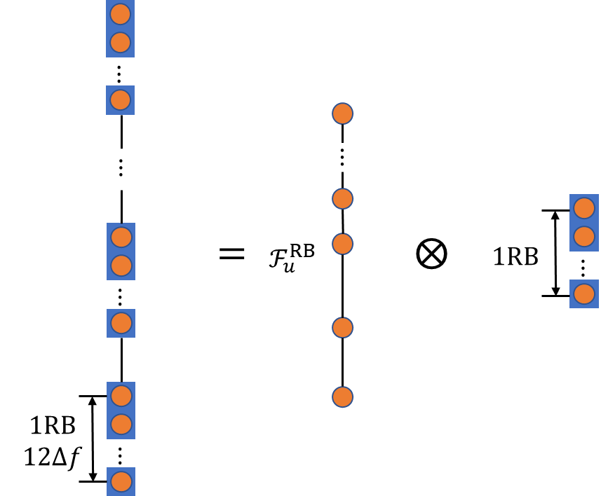
Figure 7 Sparse frequency-domain resource allocation based on RB
(a) (b)
Figure 8 Range estimation periodogram for frequency-domain sparse signals based on RB.
Figure 8 shows the range estimation periodogram of a frequency-domain sparse signal based on RB units. The blue curve represents the periodogram of the non-uniform sparse portion of the RB resource set; the yellow curve shows the periodogram of the vector of contiguous subcarriers within an RB; and the orange curve depicts the actual periodogram of the sparse signal. It can be seen that the periodogram of the resource index vector inherently has a 12-fold sparsity, thereby reducing the unambiguous sensing range by a factor of 12. Within each unambiguous period, numerous irregular high sidelobes exist due to the non-uniform sparse allocation. In contrast, the periodogram of the vector of contiguous subcarriers within an RB is a sinc function, exhibiting only a single mainlobe and some lower sidelobes. The low sidelobes of the RB vector suppress the high sidelobes of the resource set vector outside the mainlobe, so that the high sidelobes in the final periodogram of the overall sparse resources only appear within the mainlobe of the RB vector's periodogram.
Proposal 3: 3GPP should investigate the sparse allocation of time‑frequency resources in the PDSCH/PUSCH channels for ISAC users, so that the sensing performance (i.e., resolution, maximum unambiguous range, and target detection accuracy) achievable with the partial bandwidth occupied by each user can approach that of the full system bandwidth. Since the time‑frequency resources corresponding to user data are allocated in units of PRBs, their sparse allocation exhibits block sparsity. The high sidelobes in the sensing periodogram then appear only within the mainlobe region of the periodogram of the RB‑vector or slot‑vector, which requires focused attention and resolution.

4. Conclusion
In this contribution, we propose waveform enhancement for 6G ISAC, based on adopting sparse time‑frequency resource allocation in existing OFDM‑based waveforms.
Observation 1: If the various reference signals of 5G NR are reused for target sensing, under the same beam, the SSB with its contiguous time‑frequency resource allocation provides low sensing resolution. In contrast, DMRS, PT‑RS, and CSI‑RS occupy time‑frequency resources in different sparse patterns, which can achieve higher sensing resolution but face issues such as reduced unambiguous range or high sidelobes.
Proposal 1: 3GPP should investigate enhancing the sensing performance of OFDM‑based waveforms by improving existing reference signals or designing dedicated sensing reference signals through sparse time‑frequency resource allocation, thereby achieving a trade‑off among resolution, unambiguous range, and sidelobe levels.
Observation 2: For a given number of resources, as the sparsity factor increases by a factor of $η$, the uniformly sparse resource allocation method improves the resolution by a factor of $η$, while the unambiguous range is reduced by a factor of $η$.
Observation 3: The non‑uniform sparse time‑frequency resource allocation scheme can achieve higher sensing resolution while keeping the maximum unambiguous range unchanged; however, the sidelobe level is increased along with it, thus requiring the design of sparse resource sequences with low sidelobes.
Observation 4: Sparse time‑frequency resource allocation based on specific structures, combined with autocorrelation‑based signal processing methods, enables a limited number of sparse resources to achieve sensing performance comparable to that obtained with a larger bandwidth‑time product.
Proposal 2：3GPP may enhance existing reference signals or design dedicated sensing reference signals through three approaches, namely, uniform sparse, non-uniform sparse, and structured sparse resource allocation, in order to improve the sensing performance of a limited number of time–frequency resources and meet the sensing requirements of different ISAC scenarios. Their key features are summarized below.
Sparse Pattern | Resolution | Unambiguity | Sidelobe | Allocation flexibility
Uniform sparse | high | low | Low | Medium
Non-uniform sparse | high | high | High | High
Structured sparse | high | high | Low | Low

Observation 5: Compared to reference signals, the PDSCH/PUSCH channels occupy a larger amount of time‑frequency resources, enabling better sensing performance in terms of both resolution and estimation accuracy. However, the sensing resolution achievable for a single user is limited by its allocated contiguous bandwidth, which in turn constrains the overall sensing performance of the system.
Proposal 3: 3GPP should investigate the sparse allocation of time‑frequency resources in the PDSCH/PUSCH channels for ISAC users, so that the sensing performance (i.e., resolution, maximum unambiguous range, and target detection accuracy) achievable with the partial bandwidth occupied by each user can approach that of the full system bandwidth. Since the time‑frequency resources corresponding to user data are allocated in units of PRBs, their sparse allocation exhibits block sparsity. The high sidelobes in the sensing periodogram then appear only within the mainlobe region of the periodogram of the RB‑vector or slot‑vector, which requires focused attention and resolution.

Reference
- Chairman’s notes for 3GPP TSG RAN WG1 Meeting 124b, Malta, MT, April. 13th ~ 17th, 2026

